***SQL Case Study***

Stark Tutorials Database System

This database contains the details of the students, what subjects are they have in their course.

The details of the teachers what subject they are going to teach

The details of the Head of Department of every teacher

The fees Structure of Courses

The details of Accountant which are accepting their fees and head of the accountants

1. Creating Tables in Database:
2. HOD Details: This contains the details of the HOD of each Course



1. Teachers Details: This table contains the details of the subject they are teaching and their salary details



1. Students Table: This table contains the details of the student and their course details



1. Accountants Table: This table contains the detail of accountants who have received fees from the students



1. Fees Table: This table contains the fees structure of each course



1. Database Tables:
2. HOD table:

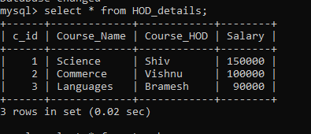

1. Teachers Table:

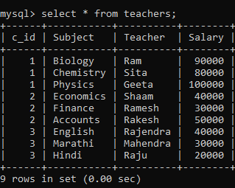

1. Students Table:

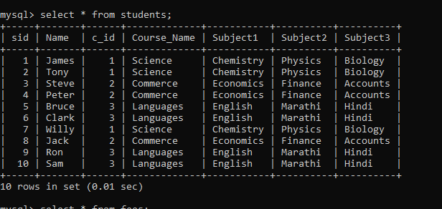

1. Fees Structure Details Table:

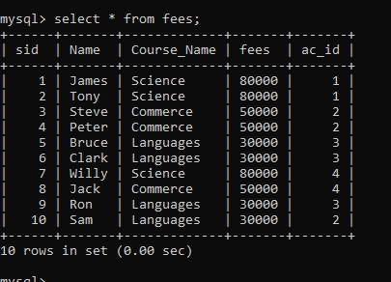

1. Accountants Table:

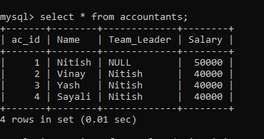

1. 30 Queries of the Database:
2. Write a query to all the details of science students

ANS:

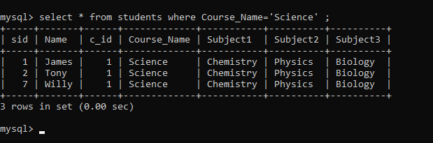

1. Write a Query to Show all Names whose names starts with S

ANS

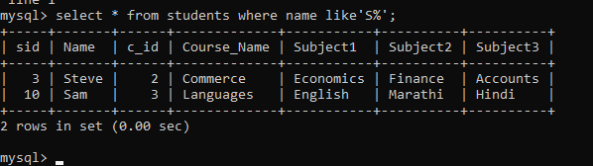

1. Write query to group of students of each course

ANS

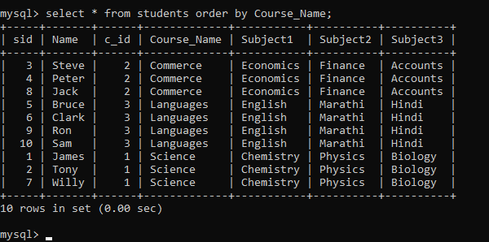

1. Write query to show max salary from teacher’s table

ANS:

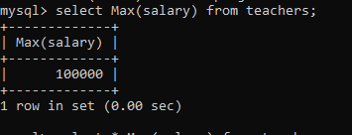

1. Write query to show students name who are studying Chemistry or Accounts

ANS:

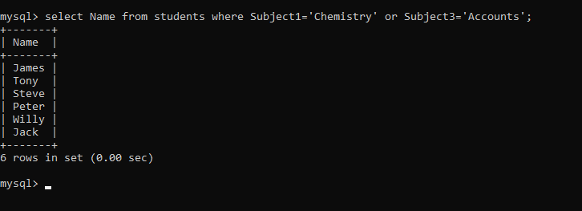

1. Write a query to show teachers who have salary between 40000 and 80000

ANS:

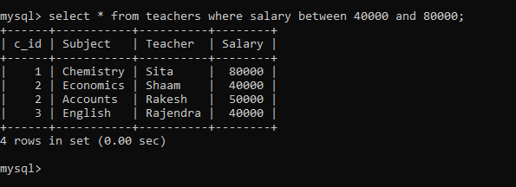

1. Write a query to show fees table in salary descending order

ANS:

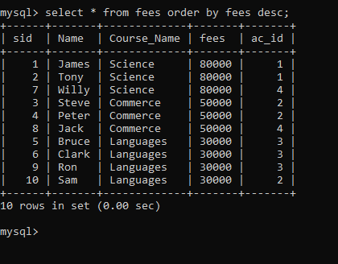

1. Write query to give all the details of accountant who has highest salary

ANS:

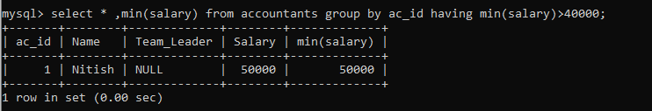

1. Add Location column in students and Building locations in Teachers

ANS:

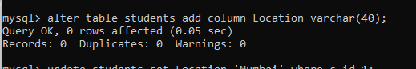

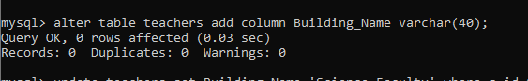

1. Insert values in Location and Building Name

ANS:

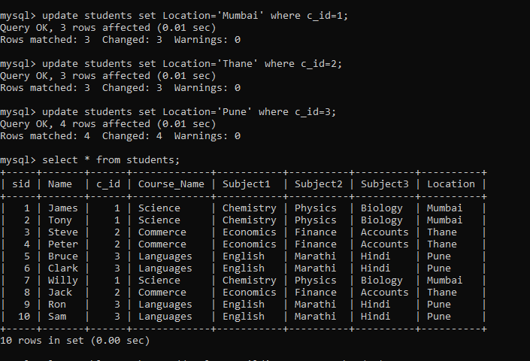

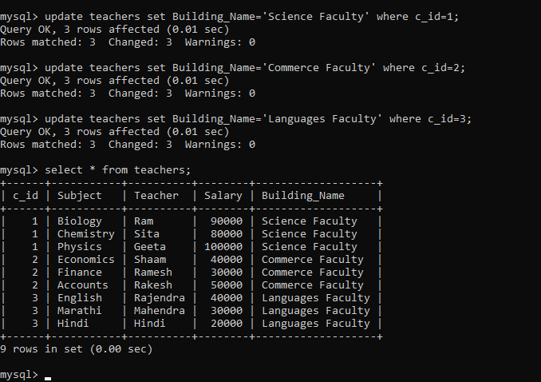

1. Write a query to show students their subjects’ teachers and HOD

ANS:

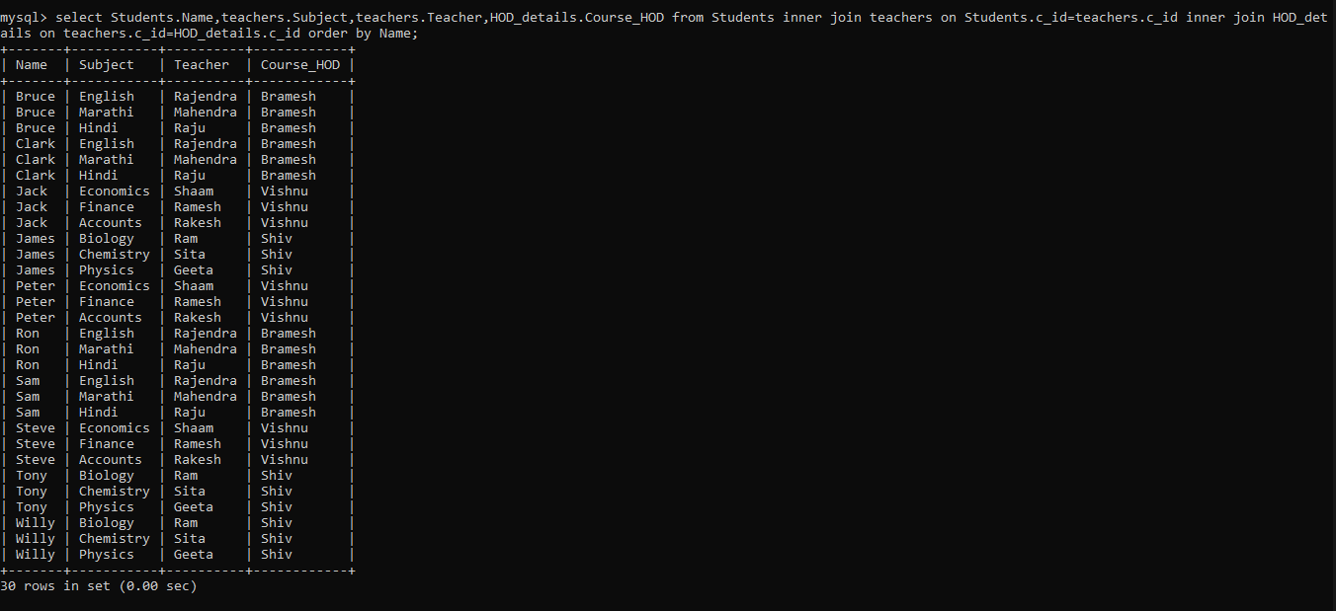

1. Write a query to show new teachers their details

ANS:

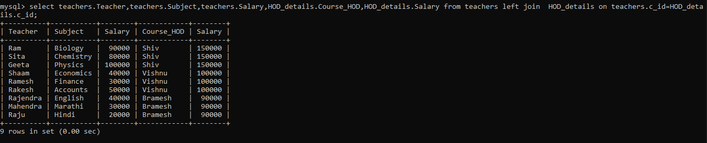

1. Write a query to show HODs their subjects

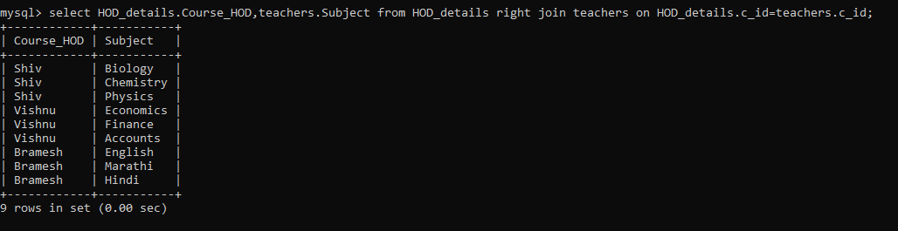

1. Write a query to show HODs which student come under his guidance

ANS:

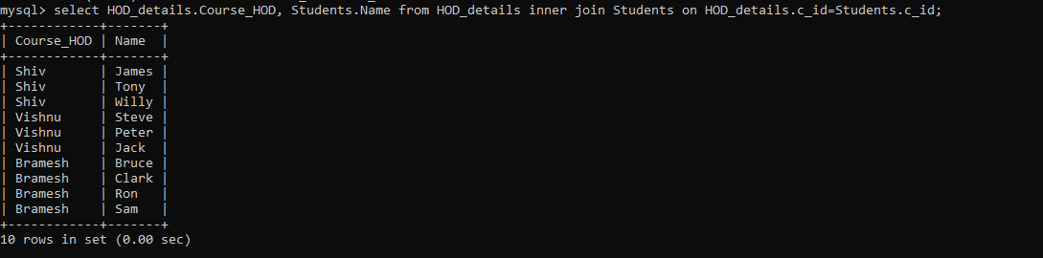

1. Write a query to show Locations of students what are their subjects and show where their class are

ANS:

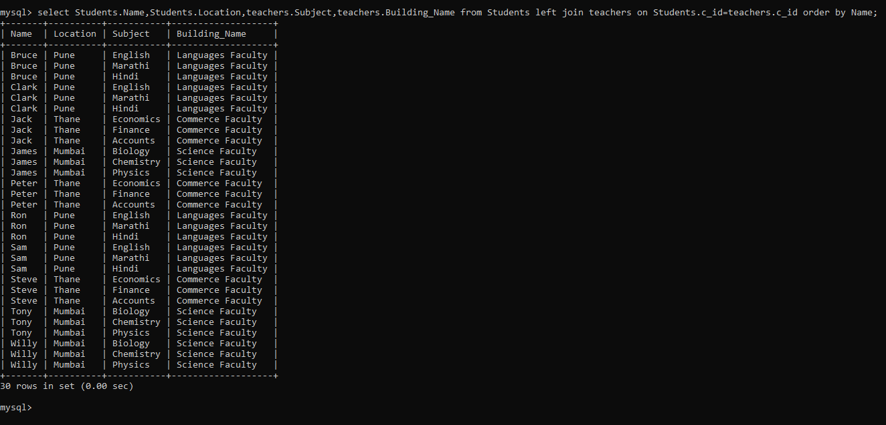

1. Write a query to show students their course fees

ANS:

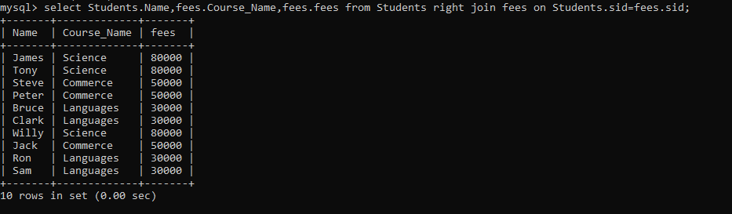

1. Write query to show accountants name to whom students have paid and show how much with course name

ANS:

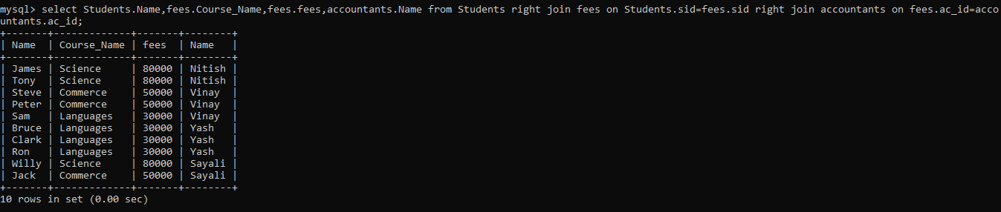

1. Make a cross join on Accountants and fees table

ANS:

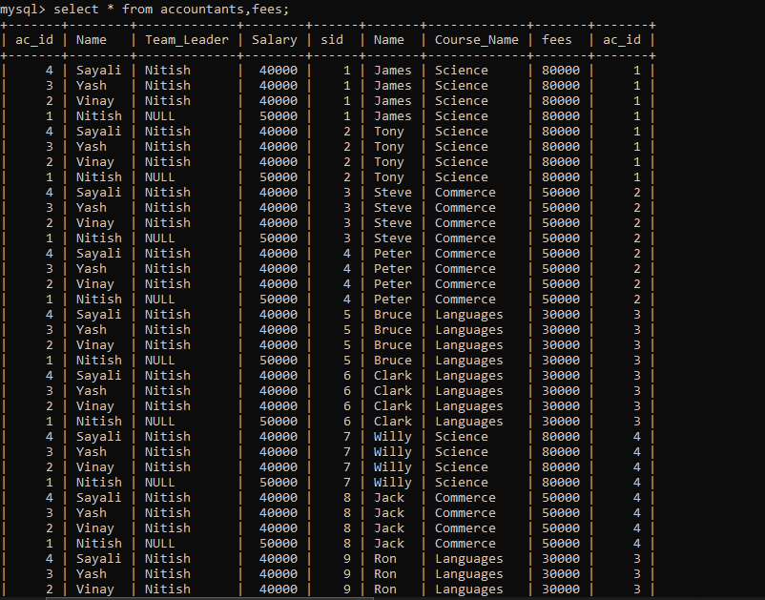

1. Make a self-Join

ANS:

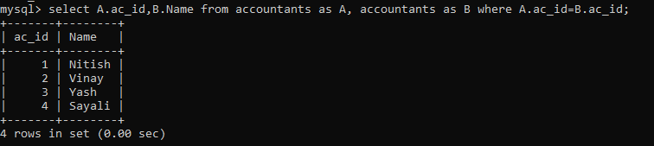

1. Join every table and make a ‘VIEW’

ANS:

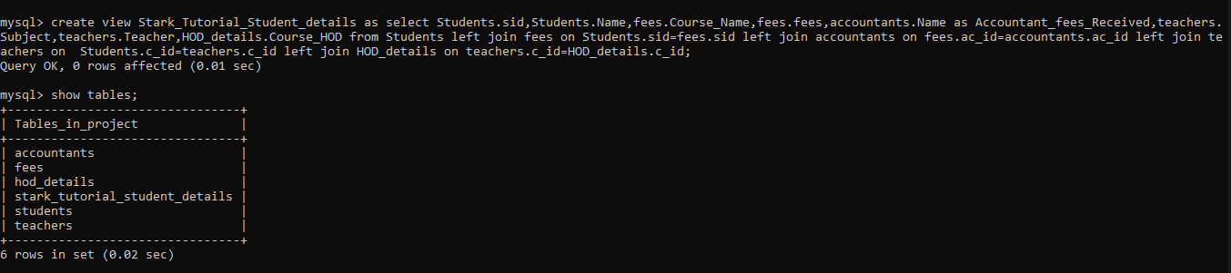

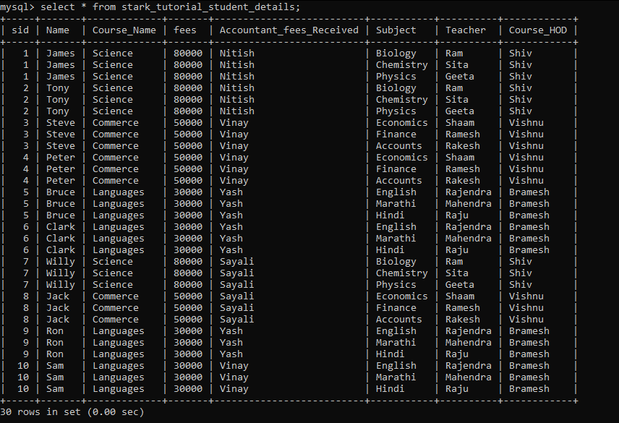

1. Write query to find the salary of Teachers whose salary is greater than the salary of Teacher whose Subject is Economics?

ANS:

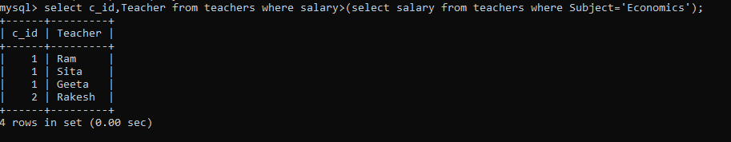

1. Write a query to find the Teachers who all are earning the highest salary?

ANS:

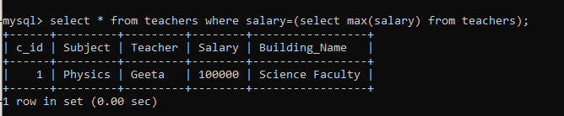

1. Write a query to find the Teachers who all are earning the 2nd highest salary?

ANS:

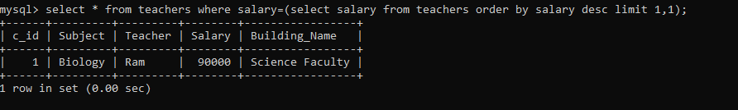

1. Write query to find the Teacher whose salary is less to salary of at least one Teacher whose subject is Accounts?

ANS:

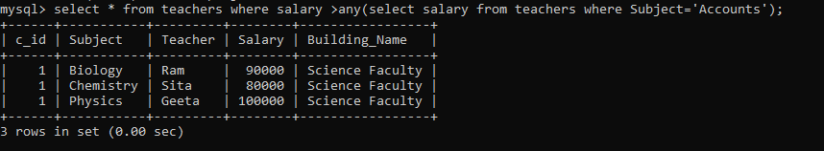

1. Write query to find the student whose fees is equal to fees of at least one Students in sid=4?

ANS:

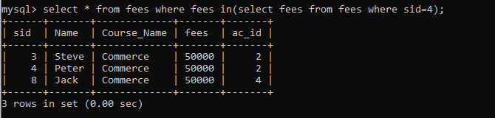

1. Write query to show accountants who collected fees of all commerce students

ANS:

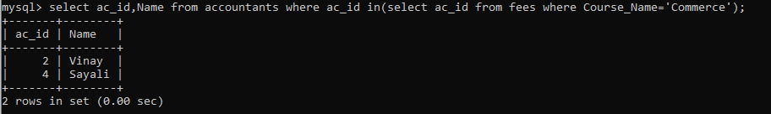

1. Write a query to show students name who are studying from Rakesh Sir?

ANS:

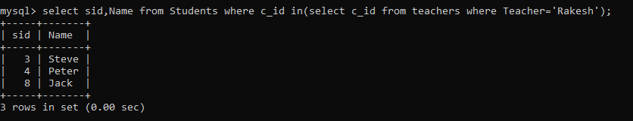

1. Write a query to highest salary teacher comes under which HOD?

ANS:

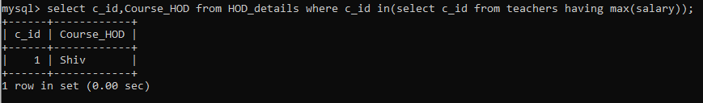

1. Write a query to show teacher’s subject comes under Bramesh HOD?

ANS:

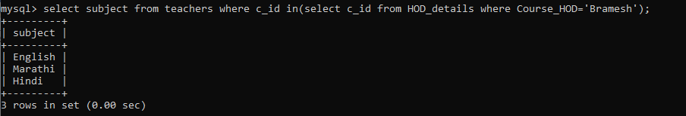

1. Write a query to show student’s location whose fees are less than 50000?

ANS:

